## Site Brainstorming

* <https://www.mypersonaltrainerwebsite.com/blog/the-20-best-personal-trainer-website-designs>
  + <https://www.armourycoachingstudio.co.uk/>
  + <https://go.fitscript.me/masterclass-video?el=IGMFIT>
  + <https://www.markpersonaltraining.com/>
  + <https://mattroberts.co.uk/>
* <https://www.jessicamanning.com/>
* <https://www.pilatesbyamanda.com/>
* <https://scottlaidler.com/>

## Site Design ideas

The site design I went with is one page that utilizes scrolling to create different sections. Theres a nav tab that will follow the viewer as they scroll which can be used to jump between the different sections. The sections of the site are as followed:

### Section 1 About Trevor

This section is meant to describe Trevor and let a potential client get to know him a bit. it also provides contact information under a picture of him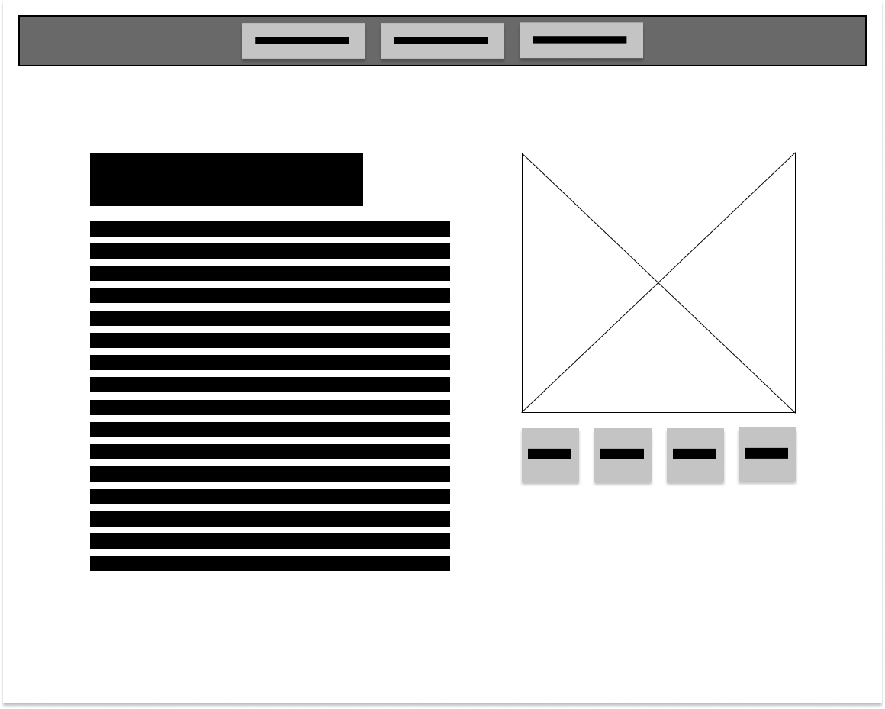

### Section 2 – what Trevor does

This section could be combined into section one, though felt having a dedicated place for a client to understand what Trevor trains/specializes in was better for organization. This section has a couple different layouts designed for it, and are as followed

#### Layout 1:

The idea behind this layout is to provide brief description of what Trevor does as well example image. This is design was meant to be compact compared to the others

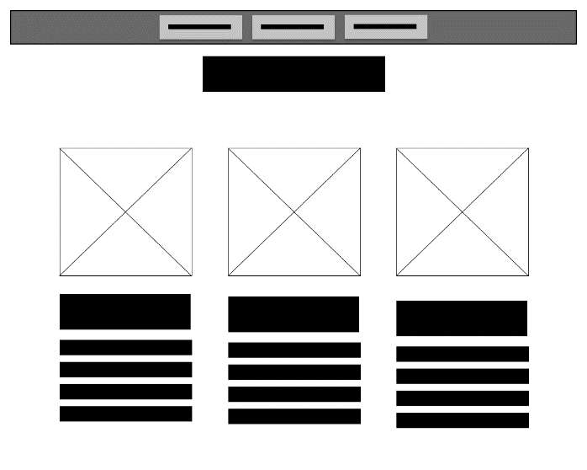

#### Layout 2:

Layout two is meant to be less compact and provide a dedicated space for a single thing Trevor does. The viewer can then hit the arrows on either side to head to the next thing about travers training program

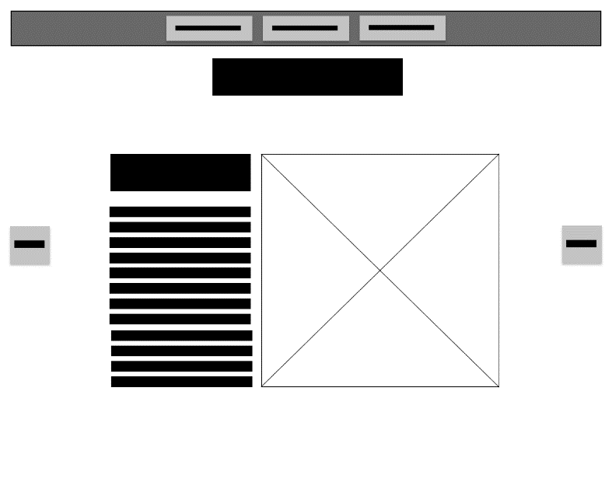

#### Layout 3:

This layout is meant allow is meant to be compact but allow for still some dedicated space for each aspect of Trevor’s program/what he does

#### 

### Section 3

Section 3 is meant to highlight clients Trevor’s most proud of training. It also has space for any comments/review that the past client has about Trevor. This section could also not be just for featured client but could for all clients.

#### Layout 1:

Layout one for this section is a is meant to show varied number of clients at once. initially showing only their picture and then whined hover, it ‘ll show their name, and either reviews or about them/what they did with Trevor

|  |  |
| --- | --- |
|  |  |
| Normal state | hovered |

#### Layout 2

This layout follows a similar design layout 1 does, but instead doesn’t required hovering

#### 

#### Layout 3

This layout does a similar to the about ones but is meant to be more dedicated to a single client

#### 

#### Layout 4:

This layout is similar to one but rather then having the ability to shift between clients. They are laid out as a grid, which can be hovered over to get information about them.

